**Pancasila**

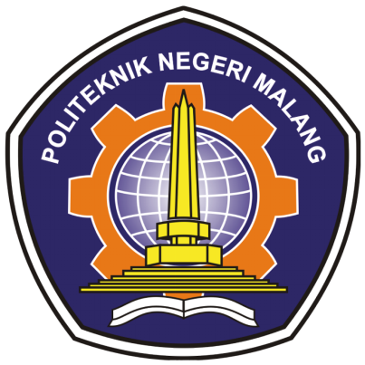

**From:**

AL AZHAR RIZQI RIFA’I FIRDAUS

**Class:**

1 I

**Absence:**

01

**Major:**

Information Technology

**Study Program:**

Informatic Engineering

**Question**

1. types of ideologies of countries in the world and examples.

2. differences between open and closed ideologies and examples

3. ideologies that once existed but now do not exist

4. difference between socialist and communist

5. Ideologies that have been implemented in Indonesia

6. Why communism is not suitable in Indonesia

**Answer**

1. Types of ideologies

* Ideology of Capitalism

The ideology of capitalism is a well-known ideology in the world. The ideology of capitalism was popularized by a father of world economics, Adam Smith.

This understanding was initiated by Adam Smith because he did not agree with the ideology of mercantilism that was developing at that time. Adam Smith's theory of the ideology of capitalism which is quite widely known is the theory of invisible hand.

The ideology of capitalism emphasizes the control of capital by private parties where the state has no right to regulate and make laws that can complicate their business. Examples of countries that use capitalist ideology are United States, Argentina. Bolivia.

* Liberalism Ideology

This ideology emphasizes the freedom of each group to be able to express their own desires without any restrictions from other parties, as from the origin of the word liberal which means freedom. This ideology considers that everyone should have an equal opportunity to achieve something. Each individual has the right to self-determine various public rights such as political rights, religious rights, and various other rights. Examples of countries that use capitalist ideology are Peru, Uruguay, and Venezuela.

* erve
* rververv

1. Differences between open and closed ideologies

Characteristics of open ideology

- The values applied cannot be imposed from outside, but must be in accordance with the values and norms of the surrounding community.

- The basis is not from a group, but community deliberation

The values are basic

- Not made by the state, but from the culture of the people The content is not rigid, so that each generation can interpret it

- Can inspire people to take responsibility

Characteristics of a closed ideology

- Authoritarian in nature, the state becomes the ruler

- Totalitarian The result of the group to change society

- People are required to make sacrifices

- Not only contains values and norms, but also certain demands

1. efewf
2. Points of Distinction

* Communism

= Communism is an ideology, philosophy, and political action whose main goal is to create a society without social classes.

* Socialism

= Socialism is a view of life and the teaching of a society that controls the means of production and the results are distributed equally.

1. a. Communist ideology

Communism is an ideology. The adherents of this understanding come from the Manifest der Kommunistischen written by Karl Marx and Friedrich Engels, a political manifesto first published on February 21, 1848 the theory of communism is an analytical approach to class struggle (historical and present) and welfare economics which later became one of the most influential movements in the world of politics.Communism at the beginning of its birth was a correction to the understanding of capitalism in the early 19th century, in an atmosphere that considered that workers and peasants were only part of production and were more concerned with economic welfare. However, in later developments, several internal factions within communism emerged between theoretical communists and revolutionary communists, each of which had different theories and ways of struggle in achieving a socialist society to lead to what it called a utopian society.

b. Ideology of liberalism The word liberal is taken from the Latin liber meaning free and not a slave or a state where someone is free from the ownership of others. The meaning of free then becomes an attitude of the educated class of society in the West that opens the door to freedom of thought (The old Liberalism). Politically, liberalism is a political ideology centered on the individual, considered as having rights in government, including equal rights to be respected, the right to expression and action and freedom from religious and ideological ties (Simon Blackburn, Oxford Dictionary of Philosophy). In the social context, liberalism is defined as a social ethic that defends liberty and equality in general (Coady, C. A. J. Distributive Justice). According to Alonzo L. liberalism).

c. Ideology Nationalism as an ideology shows a nation that has a common culture, language and territory. In addition, there are also similarities in ideals and goals. Thus the group can feel a deep loyalty to the nation group. The ideology of nationalism was first introduced by political organizations that emerged in the territory of Indonesia. Nationalism ideology became the basis of the struggle of the Indonesian National Party (PNI) chaired by Ir. Soekarno.

d. Pancasila ideology is the basis of the state that recognizes and glorifies the existence of religion in government. So that we as Indonesian citizens do not need to doubt the consistency of the Pancasila Ideology towards religion.

1. In general, Indonesia firmly rejects communism and Zionism.

As a result of this rejection, of course the influence of communist countries can be said to be felt by the Indonesian people, even if there is a very small influence.

However, this does not mean that Indonesia is free from the influence of other ideologies, such as the influence of liberalism.

Currently, the life of Indonesian society tends to lead to a liberal life that emphasizes aspects of individual freedom.